Request Flexible Work Arrangement
This job aid outlines the process for an employee to request an Alternate Work Location arrangement. The request must comply with 33.06.01.R0.02 Alternate Work Location.

Prerequisites
The employee should have completed the TAMUC Alternate Work Location Training Course 2114546 in TrainTraq prior to submitting the AWL request.
The employee must be in a regular budgeted position for a minimum of 50% effort for a minimum of six months and be in good standing.

Getting Started
- Navigate to your Worker Profile and select Job on the left hand navigation panel and select Flexible Work Arrangements.
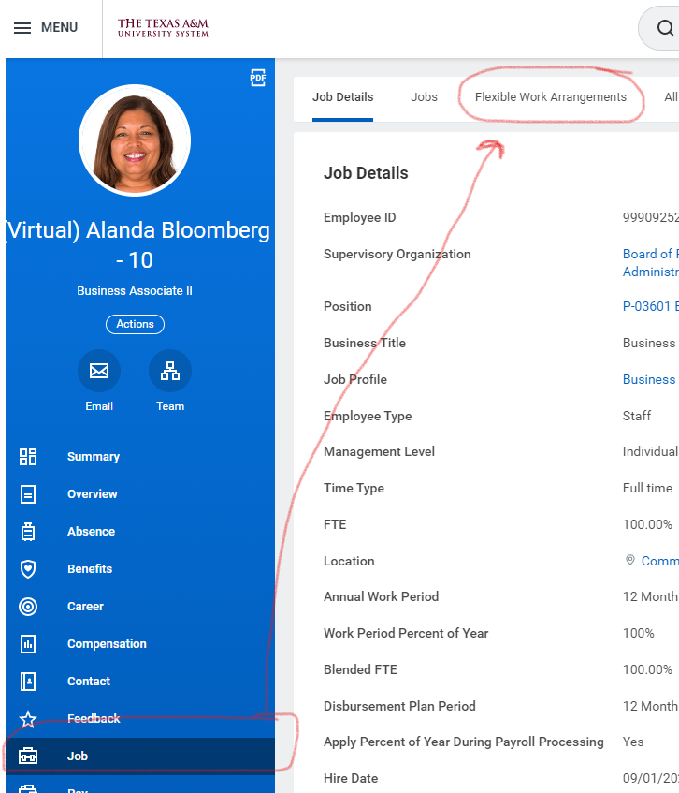

- Select Request Flexible Work Arrangement button.

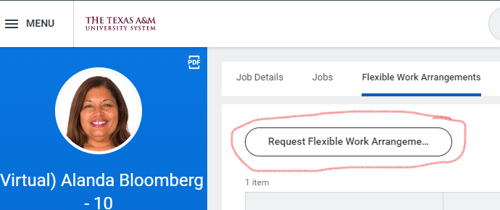

- There are six required fields to complete:
  - Start Date: The start date will automatically default to the date the request is initiated. DO NOT BACKDATE. Enter the date that the Flexible Work Arrangement will begin – today’s date or later.
  - Proposed End Date: 5/31/24 or earlier. The Proposed End Date can be no more than 12 months into the future. Annually, all flexible work arrangements will end on 5/31/XX and during the evaluation period (April – June) can be evaluated and requested to begin June 1, 20XX through May 31, 20XX.
  - Type. There are three Flexible Work Arrangement types, only Alternate Work Location should be used at this time.
    - Alternate Work Location should be selected. Select Fully Remote (if you will be completely out of the office) or Partially Remote (if you plan to work a hybrid schedule).
  - Days per Week: Enter the number of days per week you will need for the Alternate Work Location.
  - Days of the Week: Click on the three lines in the Days of the Week field and select All. Select the days of the week that will apply for this arrangement.
  - Comments: Comments are required to provide justification, details and information to support the request. The comment section can also be used to denote that the training has been completed.
  - Attachments: The training completion email is required to be uploaded in the attachment section. Do not upload medical related information into Workday. In the Description field, please enter Training Completion. In the Category field, click on the three lines and scroll to Other Documents (see below).

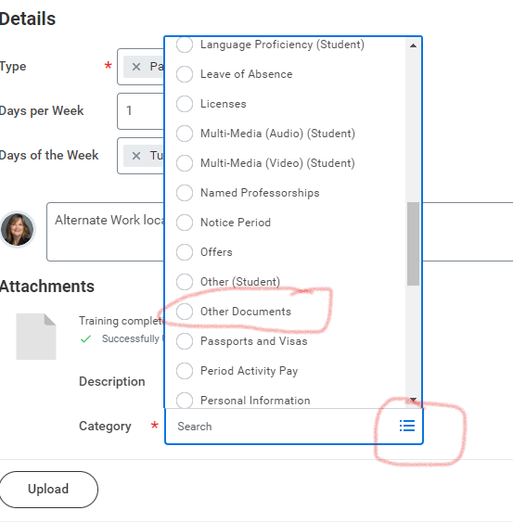

- Select Submit.

Review Documents for Request Flexible Work Arrangement
You will receive the To Do: Request Flexible Work Arrangement. This task will require you to review the document Alternate Work Location Terms and Conditions.
- Navigate to your Workday inbox and select the Request Flexible Work Arrangement To Do.
- Review the Alternate Work Location Terms and Conditions document and instructions.
- Select the I Agree checkbox.
- Enter any comments as needed and select Submit.
- Once submitted, you will need to refresh the inbox to receive the next task. (This may take a minute.)

Complete Questionnaire
Next, you will receive a questionnaire in the Workday inbox To Do: Alternate Work Location. The questionnaire is about your alternate work location. You will need to specify if your alternate work location will be outside the State of Texas. At this time, we do not allow AWL outside the State of Texas without prior approval from Human Resources and the System Office.
- Select the To Do Alternate Work Location for Request Flexible Work Arrangement and complete the questionnaire.
- Select Submit.
- Once submitted, you will need to refresh the inbox to receive the next task.

Update your Work Contact Information
You will receive the To Do: Update Your Work Contact Information.
- Navigate to the Complete To Do Update Your Work Contact Information.
- Click on the Change my Contact Information button. The button will take you to a page to update your contact information, but you must return to the inbox to submit the To Do.
- On the Change My Contact information page, scroll to the Work Contact Information Section (about halfway down the page) and Add or Edit the following two sections under Work Contact information:
  - Alternate Work Location. Enter the address of your TAMUC Office. This label may seem very confusing, but this is your university office address. The Usage field MUST BE filled out to reflect Primary Work Station. There is no asterisk to show that it is a required field. The Visibility field should be Public.
  - Additional Address. Enter the address of the location where you will be conducting work outside the premises of the university’s physical location. The Usage field MUST BE filled out to reflect Remote Work Location. There is no asterisk to show that it is a required field. The Visibility field should be Private.
- After updating your contact information, select Submit and return to your inbox to submit the To Do.

Additional Routing
The request will be routed to the Manager, Human Resources, Department Head, and Chief Executive Approver for approval.
If you need assistance with this process, please contact HR.Leave@tamuc.edu.

